**Shopsmart: Your Digital Grocery– Final Project Report**

**1. INTRODUCTION**

**1.1 Project Overview**

ShopSmart is a MERN-stack based digital grocery shopping platform that connects customers, grocery sellers, and administrators. Users can browse categories, add products to their cart, and place orders. Sellers can manage inventory and orders through a seller dashboard, while admins manage product promotions and platform governance.

**1.2 Purpose**

To build a real-time, responsive online grocery store with role-based access for customers, sellers, and admins, delivering seamless UI/UX, secure transactions, and efficient backend operations.

**2. IDEATION PHASE**

**2.1 Problem Statement**

Local grocery stores and customers often face challenges in digitizing their shopping experience. How might we streamline the grocery shopping process through a simple, accessible, and real-time web platform?

**2.2 Empathy Map Canvas**

Who are we empathizing with? Customers and local grocery shop owners  
What do they see/hear/do/feel?

* See: Disorganized item availability
* Hear: Stock issues, late deliveries
* Do: Visit stores physically or make calls
* Feel: Anxious about freshness, unplanned shopping

**2.3 Brainstorming**

**Grouped Ideas:**

* **Customer Experience:** Intuitive UI, categorized items, real-time cart
* **Seller Experience:** Inventory updates, order management
* **Admin Tools collaborative brainstorming.:** Manage sellers, promote products  
  Used sticky notes and Miro for

**3. REQUIREMENT ANALYSIS**

**3.1 Customer Journey Map**

1. Visit Homepage →
2. Browse Grocery Categories →
3. Add Products to Cart →
4. Login/Signup →
5. Checkout and Place Order →
6. Track Order →
7. Provide Feedback

**3.2 Solution Requirement**

**Functional:**

* Role-based login
* Product search, cart management, order placement
* Seller dashboard for stock & orders
* Admin dashboard for promotions

**Non-functional:**

* Responsive design
* Token-based authentication
* Scalable backend with RESTful APIs

**3.3 Data Flow Diagram**

**Level-0 DFD includes:**

* **Actors:** Users, Sellers, Admins
* **Processes**: Auth, Cart, Orders, Product Management, Promotions
* **Stores**: MongoDB collections for users, sellers, products, orders, and carts

**3.4 Technology Stack**

* **Frontend:** React.js
* **Backend:** Node.js, Express.js
* **Database:** MongoDB
* **Security:** JWT authentication
* **Architecture:** 3-tier MERN-based system

**4. PROJECT DESIGN**

**4.1 Problem Solution Fit**

Bridging local grocery stores and customers via a digital, responsive shopping experience with role-specific tools.

**4.2 Proposed Solution**

**Key Features:**

* Role-based login (Customer / Seller / Admin)
* Categorized grocery browsing
* Cart and order system
* Seller panel for inventory management
* Admin dashboard for promotions

**4.3 Solution Architecture**

User Interface (React.js)

↓ API Calls

Application Logic (Node.js + Express)

↓ MongoDB Database

Supports real-time operations, modular structure, and scalability.

**5. PROJECT PLANNING & SCHEDULING**

**5.1 Project Planning**

* Project divided into 4 Sprints
* Each sprint delivers core functionality
* Used story points, burndown charts, and velocity tracking to manage progress

**6. FUNCTIONAL AND PERFORMANCE TESTING**

**6.1 Performance Testing (UAT)**

* Secure registration/login for customers, sellers, admins
* Product cart and checkout tested
* Inventory updates from seller side
* Role access verification  
  ✅ All core features tested and validated

**7. RESULTS**

* 1. **Output Screenshots**

Home Page with flight search

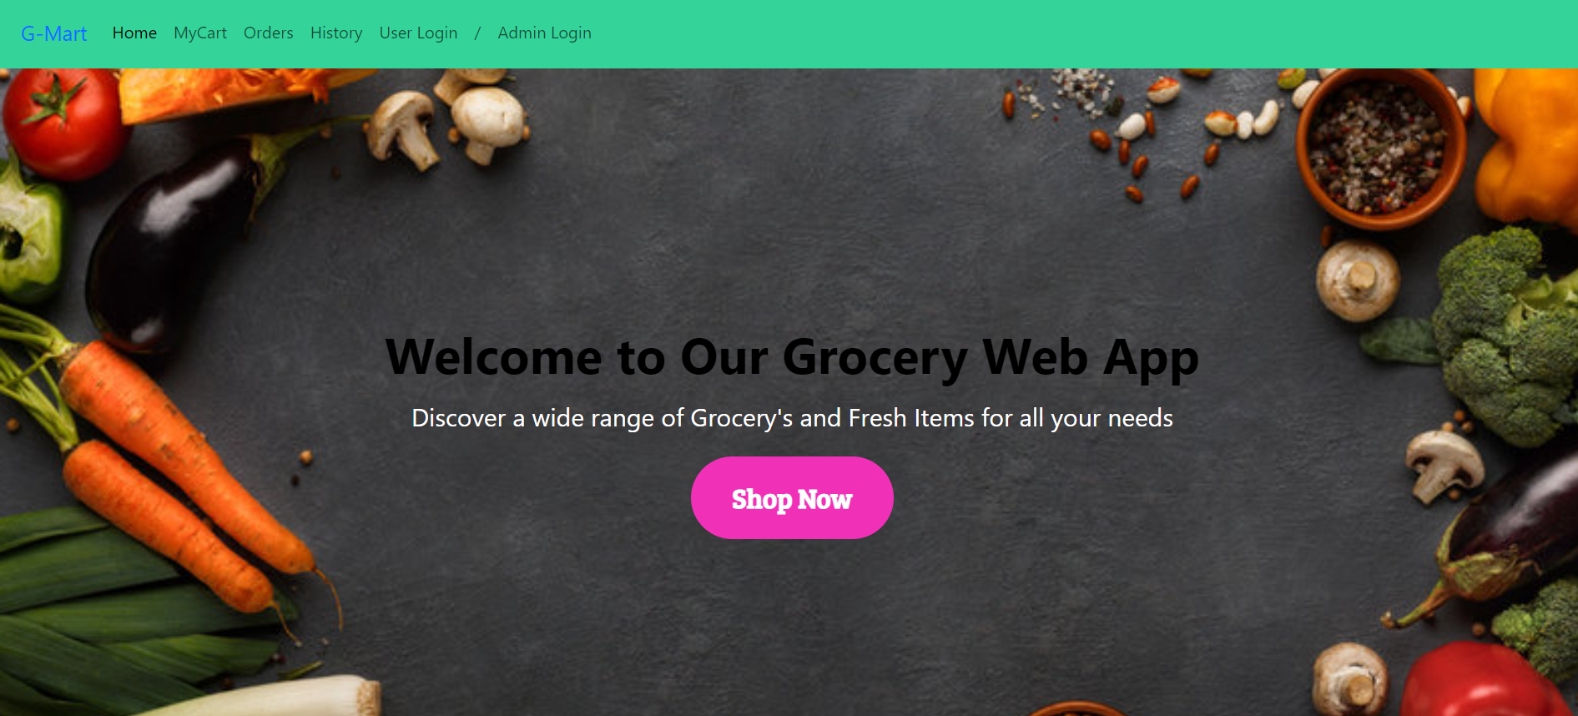

**Login form**

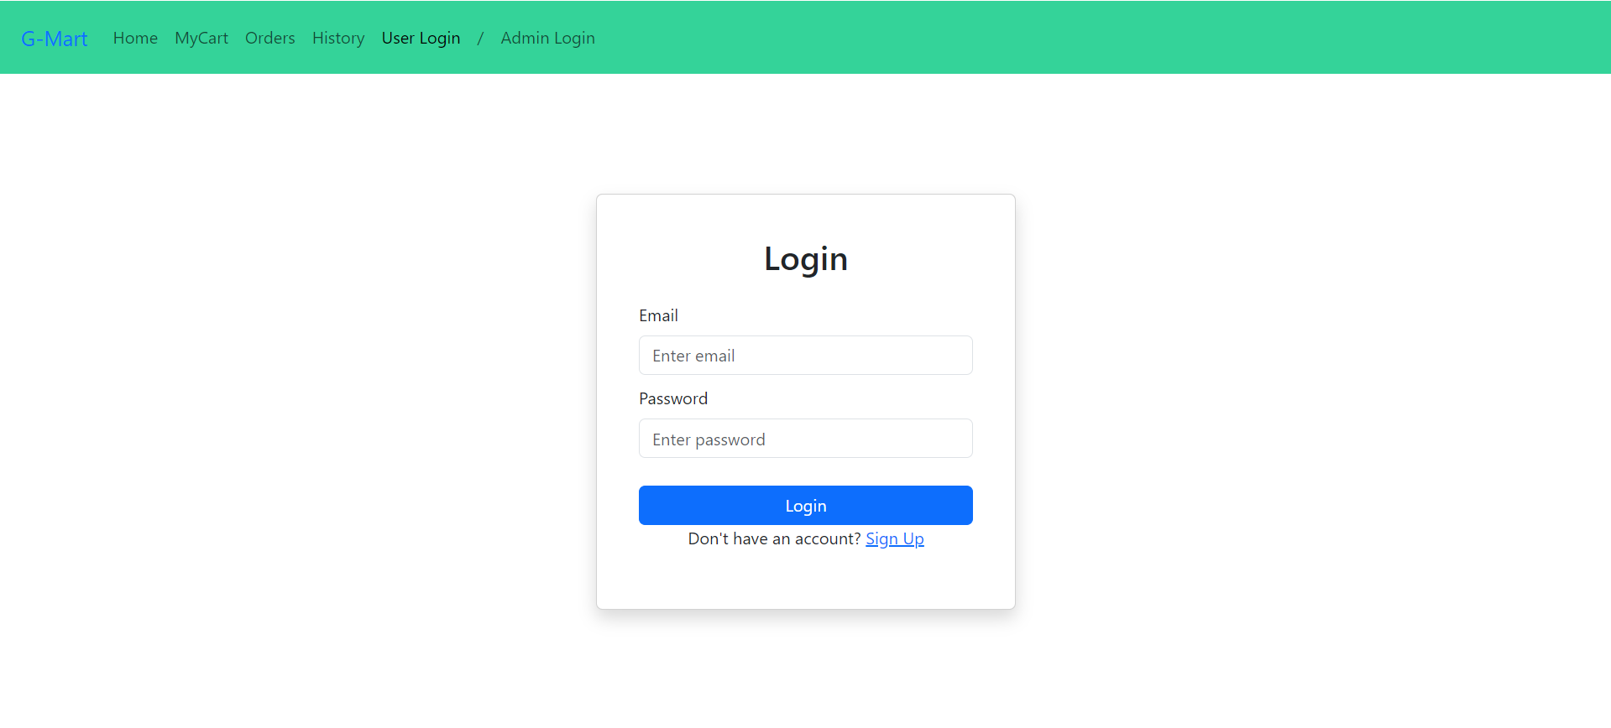

**Items Page: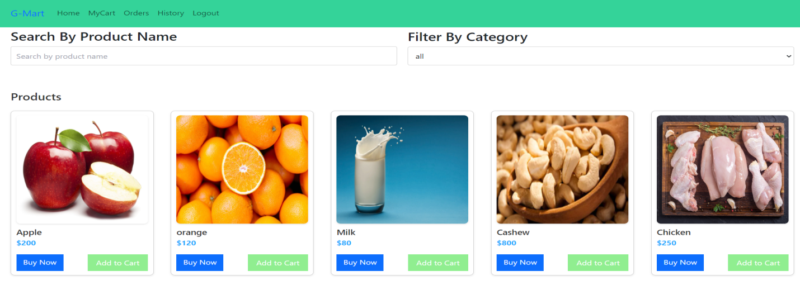 My Cart:-**

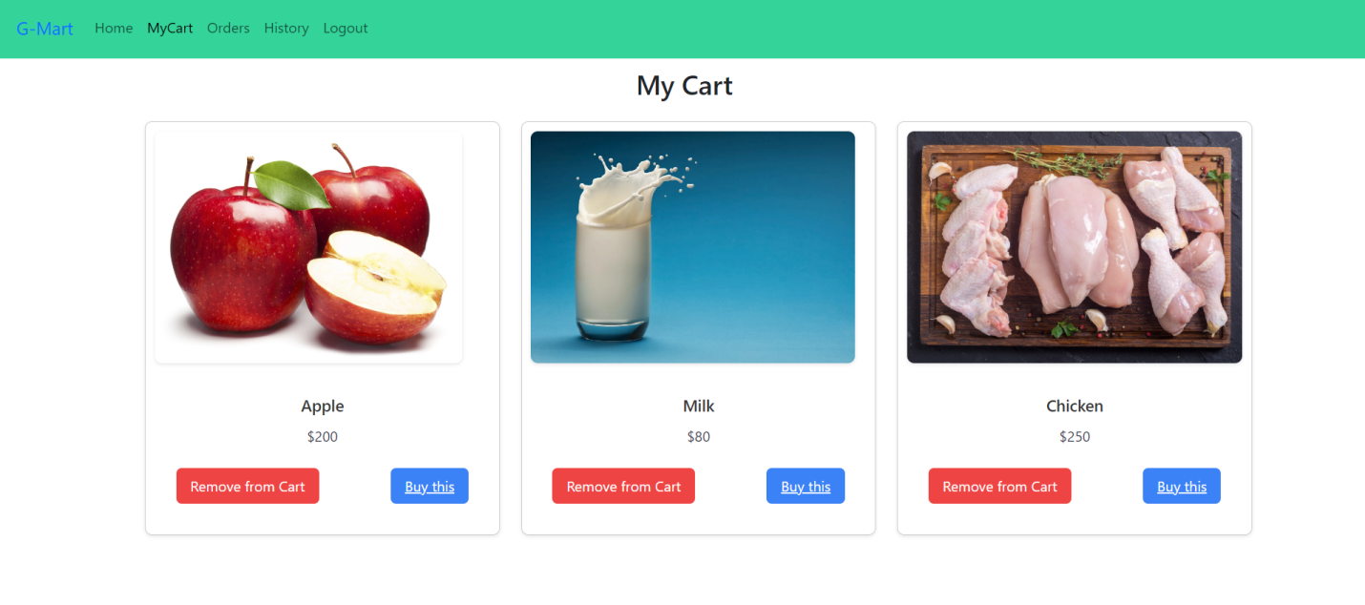

**My Orders Page:-**

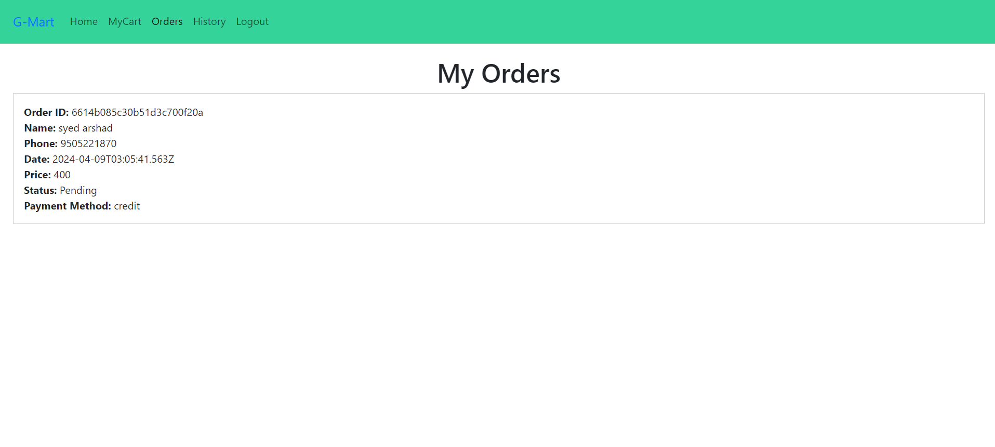**My History Page:-**

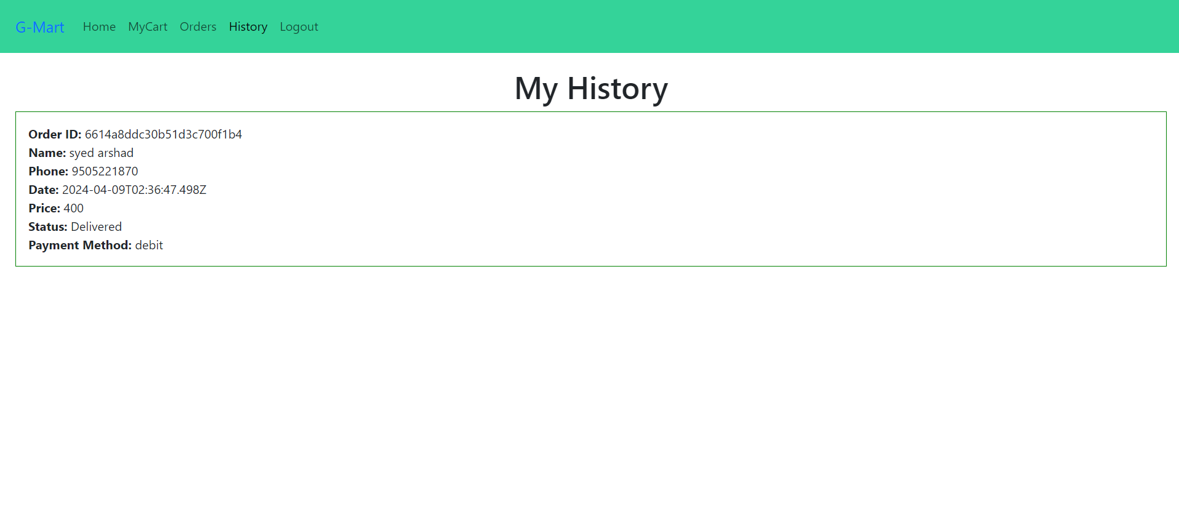

**Place Order Page:-**

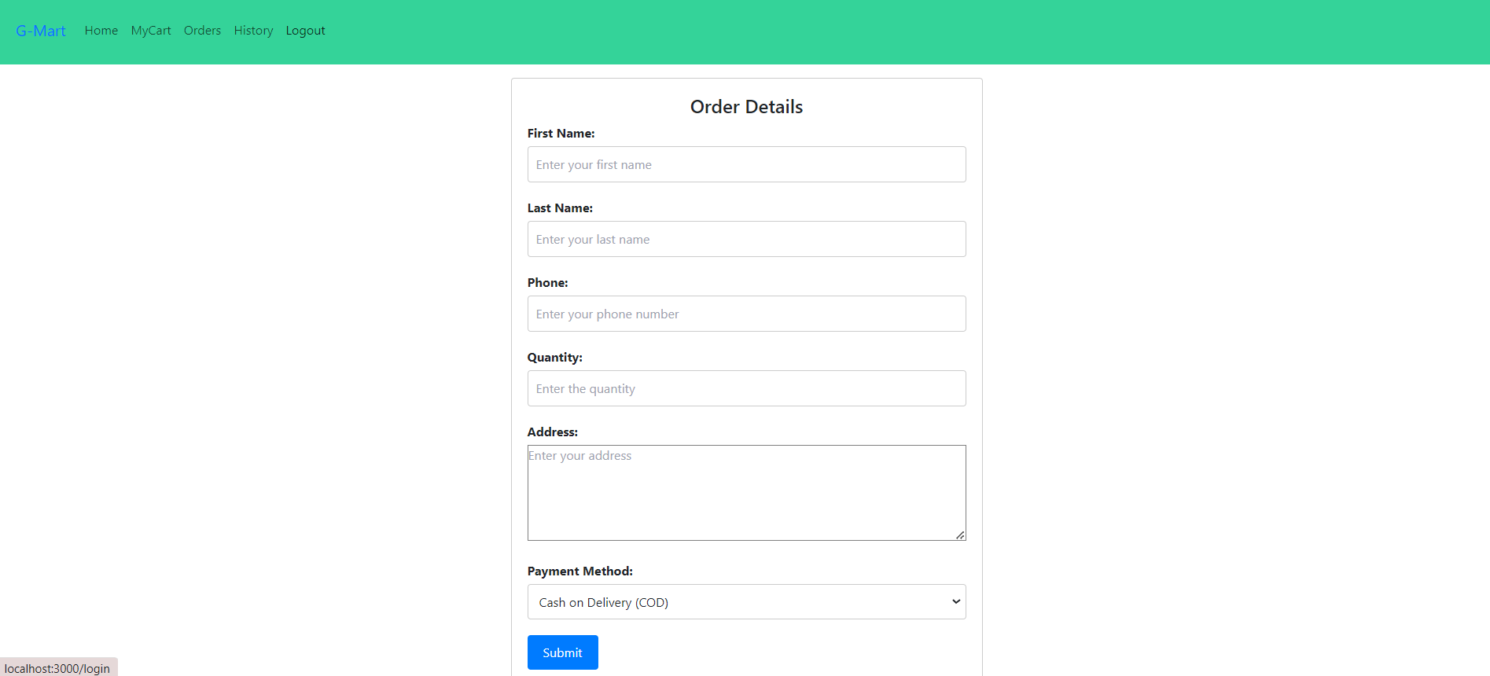

**Users Page:-**

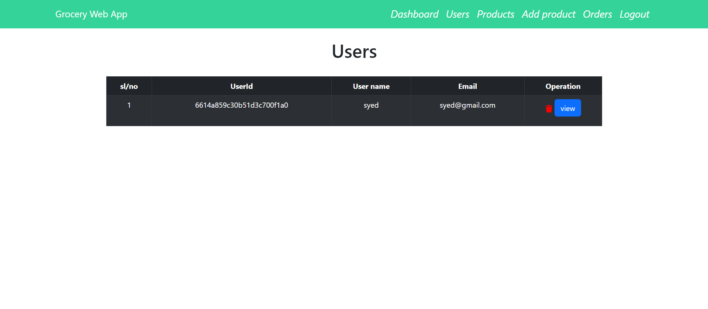

**Add Product page:-**

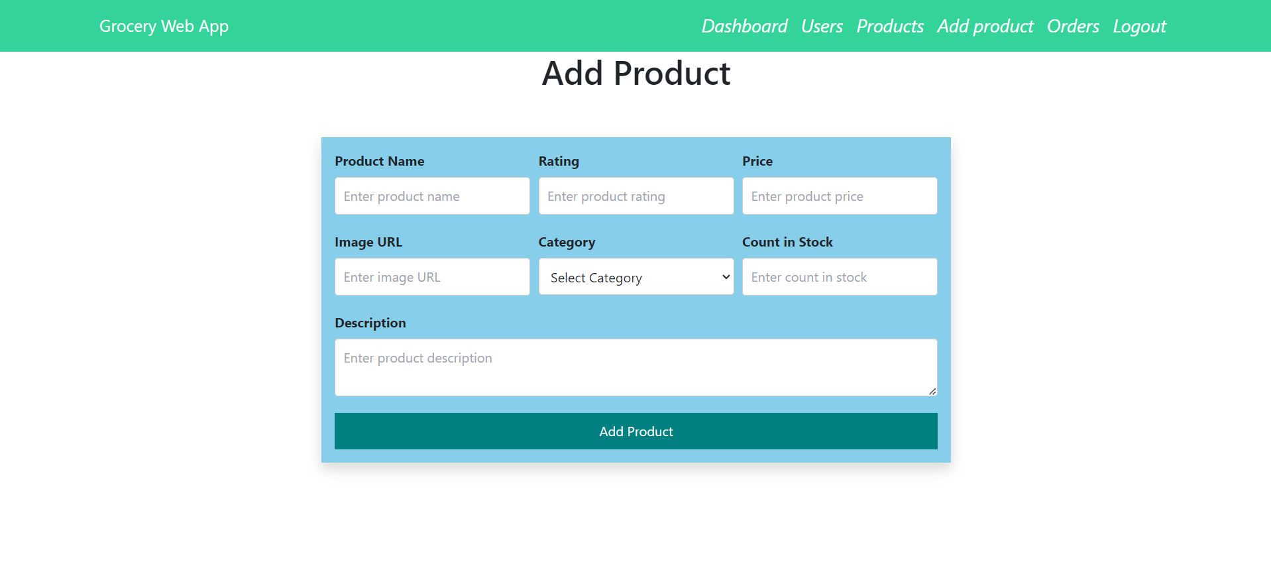

**Admin Orders Page:-**

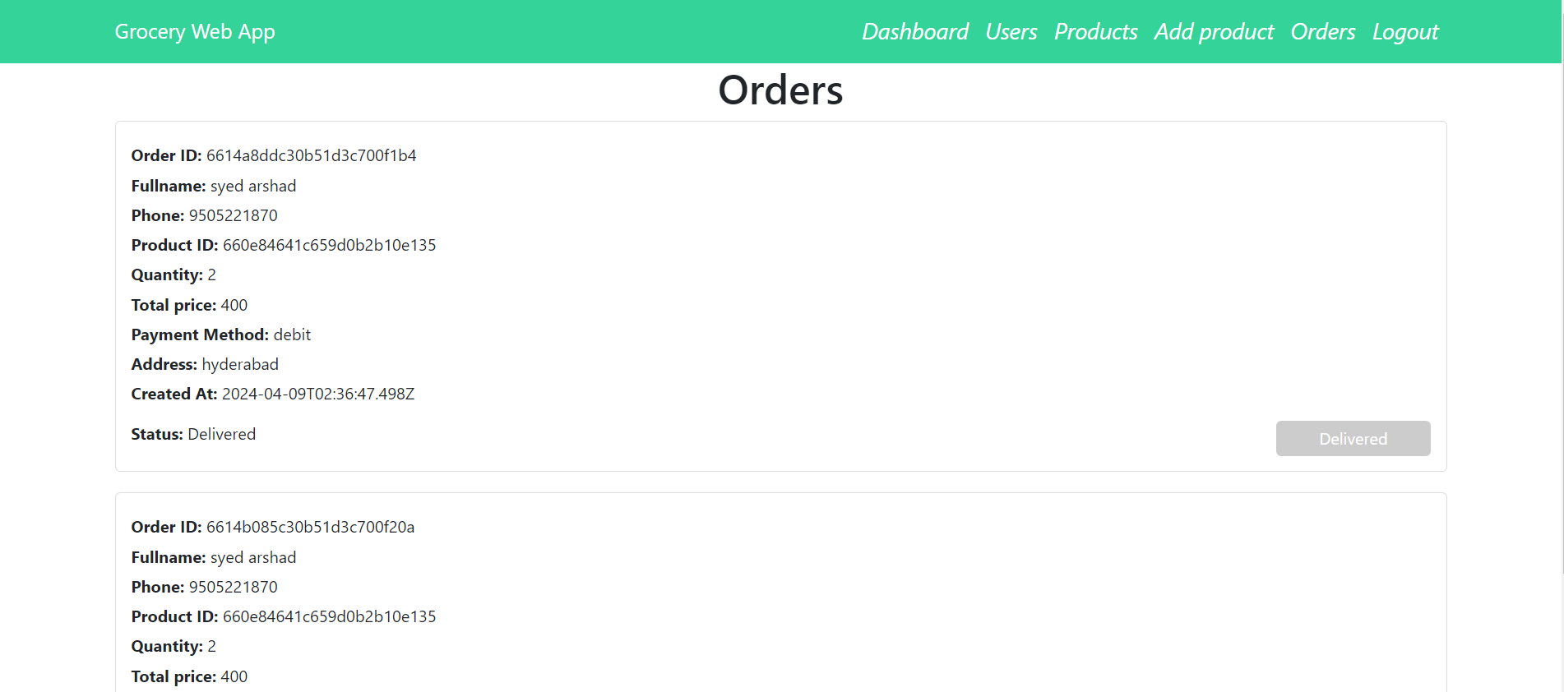

**8. ADVANTAGES & DISADVANTAGES**

**✅ Advantages**

* Real-time grocery ordering
* Role-specific dashboards
* Responsive UI on all devices
* Secure authentication using JWT
* Admin control over featured products

**❌ Disadvantages**

* No native mobile app yet
* Payment gateway integration pending (demo phase)

**9. CONCLUSION**

ShopSmart successfully simulates a full-featured online grocery platform using MERN technologies. It incorporates secure login, live cart management, seller dashboards, and an admin panel for governance.

**10. FUTURE SCOPE**

* Integrate real payment gateways (e.g., Razorpay, Stripe)
* Develop a delivery tracking system
* Create a mobile version using React Native
* Enable customer reviews and ratings
* Add sales analytics for admin/seller dashboards

**11. APPENDIX**

* **Source Code:** https://github.com/Leelamanohar123/ShopSmart-Your-Digital-Grocery-Store-Experience